Press Pass Awards 2015
Features Category
Third Place

Irish history’s most valuable gift….
… and why we must strive to preserve it

By Sarah Babiker, St Mary’s College, Naas

A social experiment went viral of a man who asked a woman eating in a restaurant for some food, she refused. The man then asked a homeless person if he could have some of the little he had and he gave him some with no hesitation. He had something the woman didn’t have: empathy. Empathy which is earned through lifes struggles.

People always ask “why do bad things happen to good people?”, but isn’t it precislely these so called ‘bad’ things that create the good in people? How can we expect pure gold without having put it through intense pressure? How can you appreciate the stars in broad daylight?

A country’s history is its people’s identity. It is preserved in the heart of the nation, passed down from parent to child for generations upon generations.To the point where a 21st century Irish teenager will talk about the1916 Rising saying “we”, never mentioning “they’’. As Martin Luther King said “ We are not makers of history, we are made by history”

One of the most powerful things Irish people can do individually and collectively is to relate international events to our history in an attempt to revive this beautiful characteristic of emapthy that we inherited from those who were not simply given it, but earned it. Everytime we see people dying as a result of famine, everytime we watch an oppressed people resisting and persisting we shouldn’t see ‘them’ we should see ‘us’. We see our struggle, our fight.

When we see child labour it brings back memories of “to hell or barbados”, where Sean O’Callaghan tells us the story of over 50,000 Irish women and children who were transported as slaves between 1652 and 1657. When we see a country’s resources being abused, when we witness unf*air trade, we remember when Irish crops were being exported out of the country during the famine. We recognise our devastation, our calamity while the refugees are stepping onto these “coffin ships’’. The Irish, of all nations understand that the only reason anyone would ever step onto “coffin ships’’ is because they know that what they’re stepping onto is safer than what they’re running away from. We relive our nation’s history through these events that we are witnessing everyday.

It’s only when a people forget about their history. It’s only when a people no longer care. It’s only when a people lose the craving to learn about those who built this country. That is when we start to lose the valuable experiences that this nation went through, aspiring towards peace, aspiring towards ‘Cothrom na Feinne’. That is when we lose the lessons we learned. In this is a devastating loss.

Simon Anholt launched a study called “the good country Index”. He explained that a ‘good’ country, in this context is the country that gives the most to humanity. Ireland ranked number one ! This came as no surprise because the Irish nation has experienced it all and the hardships we face become part of our capacity to be compassionate towards others, they become part of our gift to the world, if we let them. "Ireland did not forget it’s international obligations while building its own economy”. He concluded that we primarily admire and respect countries that contribute to the world. “It’s about attitude, it’s about a government, a people that care about the rest of the world”.

A nation who struggled and persevered and were determined to be who they truly were. A people who were stripped of their identity and culture would be ranked the 5th best country for immigrants in November 2015 and this came as no surprise because how could they commit the same injustice that they were once a victim of ?

To turn away from an oppressed nation, to turn our backs on starving people is to be unfaithful to our history. Our history literally left no room, no excuse for us to even come near injustice.

Our history is constantly screaming out “no justice, no peace”.

Silence is to be on the side of the oppressor, moreover how can we be silent in the face of injustice that this nation was once a victim of ? Ireland can’t exploit the resources of other countries. The Irish know what it is like to be dehumanised and used for cheap labour and therefore must stand up against it.

A history that put so much responsibility into our hands.
This history was especially chosen for “a fighting race” as we are called in our own national anthem, a people who could not only handle it but could power through it beautifully with hope, patience and perserverance to emerge an empathetic nation.

As we approach 2016, we remind ourselves that our mission did not end when we finally gained independence, that was a victory in our pursuit of justice, peace and prosperity, not just for us but for as many people as we can possibly reach. Our history has brought us so far and we must keep moving forward.

In the words of Michael Collins “The real riches of the Irish nation will be the men and women of the Irish nation, the extent to which they are rich in body and mind and character”.

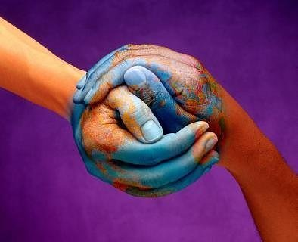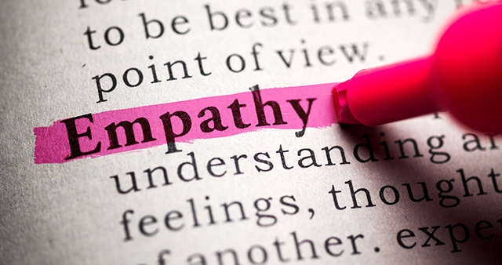

Judging Panel Citation
In less than two weeks, our country will experience a unique commemoration. 100 years since brave men and women risked their lives for their country. 100 years where the Irish fought in pursuit of justice, peace and prosperity. 100 years since the 1916 rising.

This is topic that has dominated the media in recent months. We have been inundated with books, TV shows and newspaper articles. And yet the student who wins third place in this category put forward a unique and very mature take on this topic.

It wasn’t just a re-cap of the historical events. Instead it outlines how these events impact us today teaching us to be understanding, sympathetic, empathetic. It’s clear that this writer put a lot of thought into her argument, structuring it accordingly and presenting it eloquently.

