Shops fight for Survival! 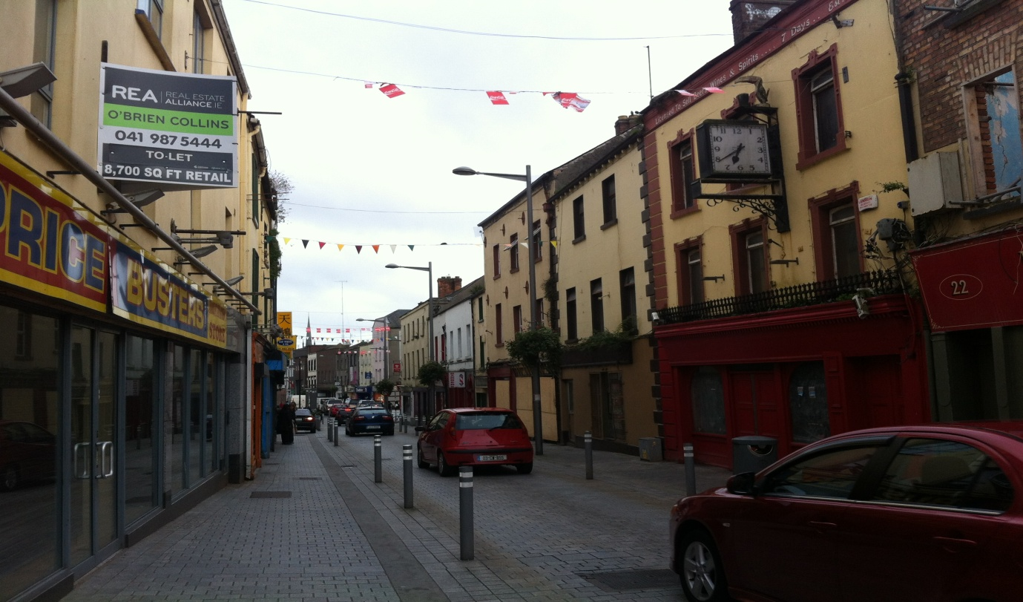
Footfall is down, rents are up and shoppers are staying away. Narrow West Street in the centre of Drogheda has seen almost all the businesses in this once thriving shopping area shut their doors in recent years.
Despite the partial pedestrianism by Drogheda Borough Council of the street some years ago, the area has failed to attract shoppers and hard pressed business owners are now struggling to survive. While other parts of the town have managed to attract shoppers in, those in Narrow West Street haven’t been so fortunate – and it’s not from want of trying. Even long established businesses such as Hurley Brothers Fine Foods Delicatessen are finding the going tough and just about keeping their heads above water.
Hurley Bros Deli was first established in June 1986 during the middle of the recession, they started off in 79 West Street but in the mid 90’s they moved 45 West Street and have remained here to this day
“In every premises there was a business, thriving everywhere busy” This is what Mr Hurley says to describe Narrow West Street when they first moved there. “Now there are only four businesses left here when there used to be around 20 or 30 when we first moved her”
“The decline came when they were doing the work on Narrow West Street, it’s got bad in the last ten years... When they done up Narrow West Street, when the work was going on that’s when the harm was done”
Mr Hurley described the Old Abbey behind his shop as “A tourist attraction that’s not being used properly”
When we asked him about what he thought about Local Heroes, he seemed to shift in his seat remembering broken promises “If you think back to that, we all did what we were told. We done up our shop fronts, we put on displays early for Christmas but when it actually came to the programme, it didn’t highlight this side of the town at all. We felt cheated by it!”
“I know some of them well and some of them cried their eyes out when the place was closed. They couldn’t sustain it anymore, sometimes they would have no customers through the full day” Mr Hurley explained the heartbreak of some of the other businesses that have closed on Narrow West Street.
Mr Hurley seems to be very prospectus about all the possibilities of the future as he explains that he has very loyal customers, a very viable business and works all day six times a week and he really believes that things will get better in a few years time.

